Deliverables:
• 7 emails - See versioning/messaging matrix below.
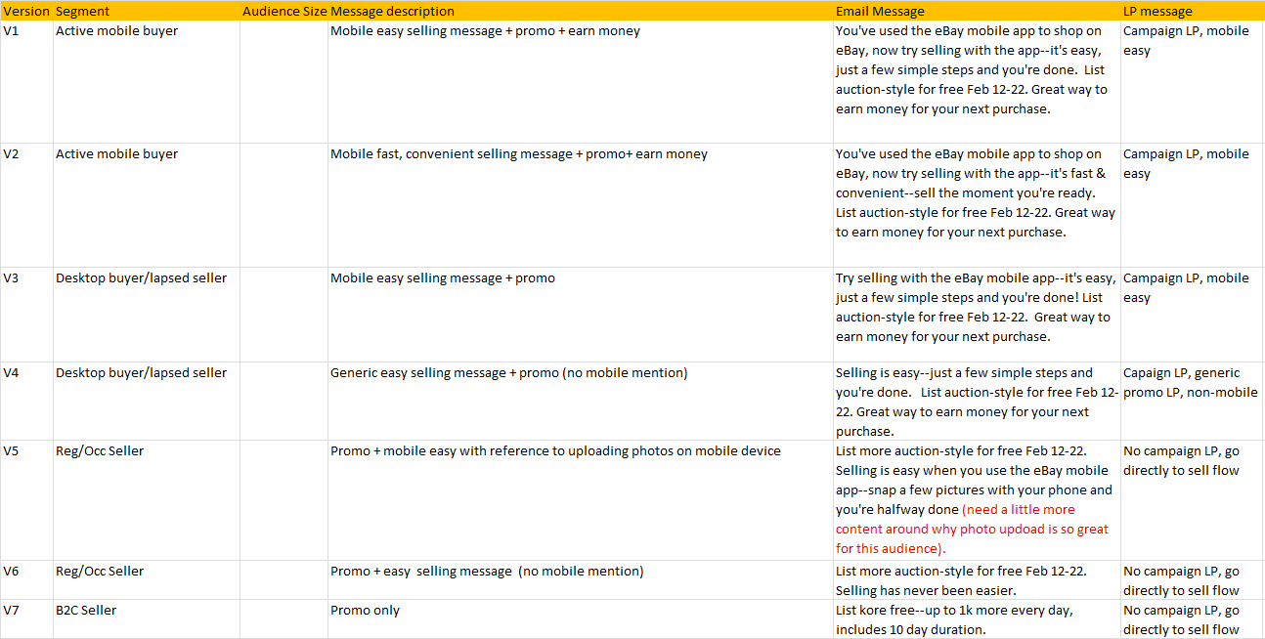 • 2 landing pages (Desktop and Mobile versions for each)
- AZIF1: AZIF promo + eBay mobile: Easy
- AZIF2: AZIF promo + eBay is easy (no mobile mention)
• 8 HPBB Billboards – 4 versions (V3-V6 above in 2 sizes each). Total 8 assets.
• Mobile RTM, 6 versions, sized as needed for each device (iPhone, Android, iPad)
- Based on Message 1 (badge + copy + mobile splash-page)
- Based on Message 2 (badge + copy + mobile splash-page)
- Based on Message 3 (badge + copy + mobile splash-page)
- Based on Message 4 (badge + copy + mobile splash-page)
- Based on Message 5 (badge + copy + mobile splash-page)
- Based on Message 6 (badge + copy + mobile splash-page)
*Not needed for B2C

Note: Copy is not final/ For demonstration only

Yesmail will design towards email Best Practices
• Selectable text
• Design will leverage C2C style guide
• Readable in images-off environments
• Bulletproof buttons
• Large-scale type
• Short, easily digestible copy
• The emails will be Mobile-Responsive

- Copy Note: Need to be sure in C2C versions not to imply that the promo is only available if you list on your mobile device. Promo is not mobile-specific and those invited are eligible if they list on mobile or desktop. There has been confusion in the past that you had to list on mobile to get the promo so we need to be careful here.

- eMail 1 (Active Mobile Buyers – eBay Mobile: Easy/Great way to make $$/AZIF offer)

- Preheader
  - First name-merge, content-relevant line, text CTA
  - Link to hosted version
  - eBay Seller Protection
- Header
  - eBay Logo
  - Navigation
    - Start Selling Now
    - Sell on Mobile
    - How to Sell
    - What to Sell
    - Success Stories
- Primary Message:
  - Imagery: TBD
  - Offer violator: List Auction-style FREE* Feb 12-22
  - Copy points to include:
    - Acknowledge that they’ve used the Mobile App to buy
    - NOW is a great time to sell
    - Selling with eBay mobile is EASY – just 3 simple steps - List it, ship it, get paid
    - Great way to earn money for your next purchase
  - Call to action:
Get started (will link to mobile easy Landing page)

- Secondary: Inspiration (See Creative Mandatories section of brief for more details)
  - Get inspired
See what eBay shoppers are buying to help you decide what to sell
Staging link: http://ebaysc.stage.liveplatform.com/what-to-sell-online
Actual URL when LTS 1/14: http://pages.ebay.com/sellerinformation/what-to-sell-online
- Legal/Unsub – Please refer to Brief for email footer terms needed

- eMail 2 (Active Mobile Buyers – eBay Mobile: Fast & Convenient / Great way to make $$/AZIF offer)

Preheader
  - First name-merge, content-relevant line, text CTA
  - Link to hosted version
  - eBay Seller Protection
- Header
  - eBay Logo
  - Navigation
    - Start Selling Now
    - Sell on Mobile
    - How to Sell
    - What to Sell
    - Success Stories
- Primary Message:
  - Imagery: TBD
  - Offer violator: List Auction-style FREE* Feb 12-22
  - Copy points to include:
    - Acknowledge that they’ve used the Mobile App to buy
    - NOW is a great time to sell
    - Selling with eBay mobile is FAST & CONVENIENT – List the moment you’re ready/ In-the-moment
    - Great way to earn money for your next purchase
  - Call to action:
Get started (will link to mobile easy Landing page)

- Secondary: Inspiration (See Creative Mandatories section of brief for more details)
  - Get inspired
See what eBay shoppers are buying to help you decide what to sell
Staging link: http://ebaysc.stage.liveplatform.com/what-to-sell-online
Actual URL when LTS 1/14: http://pages.ebay.com/sellerinformation/what-to-sell-online
- Legal/Unsub– Please refer to Brief for email footer terms needed

3) eMail 3 (Desktop Buyers/Lapsed Sellers – Introduce eBay Mobile: Easy/Great way to make $$/AZIF)

- Preheader
  - First name-merge, content-relevant line, text CTA
  - Link to hosted version
  - eBay Seller Protection
- Header
  - eBay Logo
  - Navigation
    - Start Selling Now
    - Sell on Mobile
    - How to Sell
    - What to Sell
    - Success Stories
- Primary Message:
  - Imagery: TBD
  - Offer violator: List Auction-style FREE* Feb 12-22
  - Copy points to include:
    - Introduce the Mobile App to sell
    - NOW is a great time to sell
    - Try eBay Mobile: Selling is EASY – just 3 simple steps
    - Great way to earn money
  - Call to action:
Get started (will link to mobile easy Landing page)

- Secondary: Inspiration (See Creative Mandatories section of brief for more details)
  - Get inspired
See what eBay shoppers are buying to help you decide what to sell
Staging link: http://ebaysc.stage.liveplatform.com/what-to-sell-online
Actual URL when LTS 1/14: http://pages.ebay.com/sellerinformation/what-to-sell-online

- Tertiary: Download the App – include app download buttons

- Legal/Unsub

4) eMail 4 (Desktop Buyers/Lapsed Sellers –eBay: Easy/Great way to make $$/ AZIF offer (no mobile mention)

Subject line: 2 versions for testing purposes –
- Preheader
  - First name-merge, content-relevant line, text CTA
  - Link to hosted version
  - eBay Seller Protection
- Header
  - eBay Logo
  - Navigation
    - Start Selling Now
    - How to Sell
    - What to Sell
    - Success Stories
    - Sell on Mobile
- Primary Message:
  - Imagery: TBD
  - Offer violator: List Auction-style FREE* Feb 12-22
  - Copy points to include:
    - NOW is a great time to sell
    - Selling is EASY – just 3 simple steps
    - Great way to earn money
  - Call to action:
Get started (link to non-mobile LP)

- Secondary: Inspiration (See Creative Mandatories section of brief for more details)
  - Get inspired
See what eBay shoppers are buying to help you decide what to sell
Staging link: http://ebaysc.stage.liveplatform.com/what-to-sell-online
Actual URL when LTS 1/14: http://pages.ebay.com/sellerinformation/what-to-sell-online
- Legal/Unsub

5) eMail 5 (Regular/Occasional Sellers – AZIF, Selling on Mobile is Easy)
Subject line: 2 versions for testing purposes –
- Preheader
  - First name-merge, content-relevant line, text CTA
  - Link to hosted version
  - eBay Seller Protection
- Header
  - eBay Logo
  - Navigation
    - Start Selling Now
    - Sell on Mobile
    - How to Sell
    - What to Sell
    - Success Stories
- Primary Message:
  - Imagery: TBD
  - Offer violator: List Auction-style FREE* Feb 12-22
  - Copy points to include:
    - NOW is a great time to sell
    - Try eBay Mobile: Selling is easy when you use the eBay mobile app--snap a few pictures with your phone and you're halfway done (need a little more content around why photo upload is so great for this audience).
  - Call to action:
Sell now (will link to Sell Flow)

- Secondary: Inspiration
  - Get inspired
See what eBay shoppers are buying to help you decide what to sell
Staging link: http://ebaysc.stage.liveplatform.com/what-to-sell-online
Actual URL when LTS 1/14: http://pages.ebay.com/sellerinformation/what-to-sell-online

- Tertiary: Download the App

- Legal/Unsub

6) eMail 6 (Regular/Occasional Sellers – eBay: Easy/Great way to make $$/ AZIF offer (no mobile mention)

Subject line: multiple versions for testing purposes –
- Preheader
  - First name-merge, content-relevant line, text CTA
  - Link to hosted version
  - eBay Seller Protection
- Header
  - eBay Logo
  - Navigation
    - Start Selling Now
    - How to Sell
    - What to Sell
    - Success Stories
    - Sell on Mobile
- Primary Message:
  - Imagery: TBD
  - Offer violator: List more Auction-style FREE* Feb 12-22
  - Copy points to include:
    - NOW is a great time to sell
    - Selling has never been easier
  - Call to action:
Sell now (will link to Sell flow)

- Secondary: Inspiration
  - Get inspired
See what eBay shoppers are buying to help you decide what to sell
Staging link: http://ebaysc.stage.liveplatform.com/what-to-sell-online
Actual URL when LTS 1/14: http://pages.ebay.com/sellerinformation/what-to-sell-online

- Legal/Unsub

7) eMail 7 (B2C Sellers: List more Auction-style for FREE, up to 1k more per day + get 10 day duration fee + tbd webinar)

Look and Feel: Should be more offer-focused. Merch images or Copy only is preferred
Subject line: 1 version, no testing, should highlight offer– “List 1k more for FREE each day…”
- Preheader
  - First name-merge, content-relevant line, text CTA
  - Link to hosted version
  - eBay Seller Protection
- Header
  - eBay Logo
  - Navigation – See 1/10 B2C headers – they’re slightly different for this audience
    - Start Selling Now
    - How to Sell
    - What to Sell
    - Success Stories
    - Sell on Mobile
- Primary Message:
  - Imagery: TBD / NO LIFESTYLE
  - Offer: List more Auction-style for FREE* Feb 12-22
  - Copy points to include:
    - Up to 1K more per day
    - Get 10-day duration FREE too
  - Call to action:
Sell now (will link to Sell Flow)

- Secondary: Webinar
  - Need Webinar Info – this was sent to Ashlye last week (full creative to include)

- Legal/Unsub – see Brief for how we need to treat offer language in footer for those we take directly to sell flow and not to LP.

Landing Page 1 – AZIF + Mobile

- Standard eBay Header
- Primary Message:
  - Imagery: TBD
  - AZIF Promo
  - eBay Mobile Selling is easy (expanded)
    - Include mobile stats mobile vs non-mobile (Please provide)
  - CTA: Start Selling now
- Inspiration Module:
  - Expanded inspiration grid of products – other ideas here?
- Education Module: Are you interested in re-using the video and selling guides? Video no, selling guides yes.
Selling Guides
- Mobile Module:
  - Info about Mobile selling
    - CTA: Get the apps
- Legal/ Terms
- Standard eBay footer

Landing Page 1 – AZIF (no mobile)

- Standard eBay Header
- Primary Message:
  - Imagery: TBD
  - AZIF Promo
  - CTA: Start Selling now
- Inspiration Module:
  - Expanded inspiration grid of products – other ideas?
- Education Module: Are you interested in re-using the video and selling guides? Not the video. Selling Guides yes.
Selling Guides
- Legal/ Terms
- Standard eBay footer

